**Lab 5 Activity 2 - Adding Transitions and Animations**

**Objective** - Explore how to use transitions and animations effectively to improve slide flow and emphasize key points.

1. Apply transitions to all slides, experimenting with different effects. Learn how to apply consistent or varied slide transitions to enhance the presentation's flow and maintain audience engagement.
2. Add animations to text and images, adjusting the timing. Understand how to animate slide elements to emphasize key content and create dynamic, visually engaging presentations.

**____________________________________________________________________________________**

**Solutions:**

**Task 1:**

* Go to Transitions tab and select any transition you want.
* Make sure to watch preview of how the transmission works.
* A star before slide indicates the transition is applied.

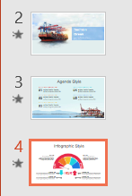

**Task 2:**

* To add animations to text and images, select your desired text.
* Go to Animations tab, and select any animation you want
* A number would be shown if the animation is applied.

